**05 Resonance**

Build a series RLC circuit, keep the output voltage value of AC source unchanged, and adjust frequency of the source signal.

A Report By

*Kibria Golam*

*2019380163*

1. When current of resistor reaches maximum Imax, the resonance frequency is found. When current of resistor reaches 0.707Imax the half power frequency is found.

Table 1

R=5-ohm, L=30mH, C= 1uF

|  |  |  |  |  |  |  |  |  |  |
| --- | --- | --- | --- | --- | --- | --- | --- | --- | --- |
| f/Hz |  |  | f1 | 896.463 | f0 | 909.726 | f2 | 922.988 |  |
| Ir/A |  |  | i1 | 0.072 | i0 | 0.412 | i2 | 0.284 |  |

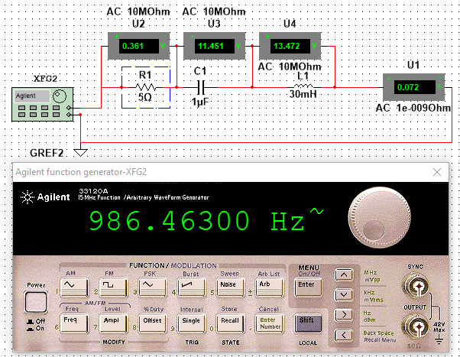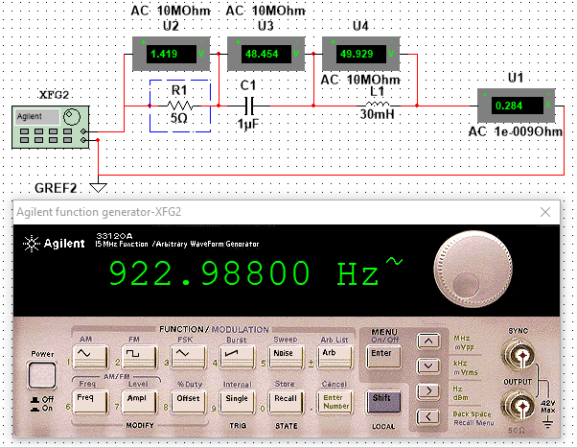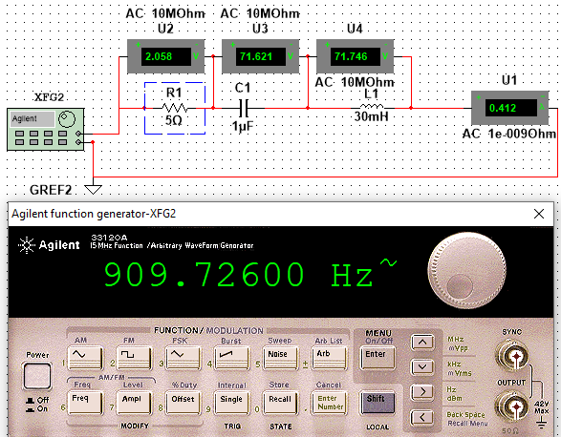

Table 2

R=50-ohm, L=30mH, C= 1uF

|  |  |  |  |  |  |  |  |  |  |
| --- | --- | --- | --- | --- | --- | --- | --- | --- | --- |
| f/Hz |  |  | f1 | 786.37 | f0 | 919 | f2 | 1051.63 |  |
| Ir/A |  |  | i1 | 0.029 | i0 | 0.041 | i2 | 0.029 |  |

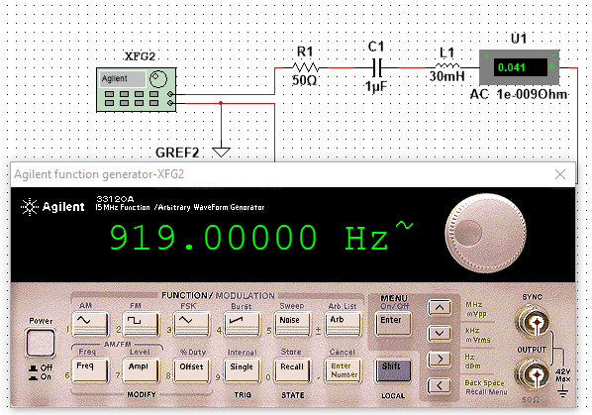

2. When voltage of resistor reaches maximum Umax , the resonance frequency is found. When current of resistor reaches 0.707Imax the half power frequency is found.

Table 3

R=5-ohm, L=30mH, C= 1uF

|  |  |  |  |  |  |  |  |  |  |
| --- | --- | --- | --- | --- | --- | --- | --- | --- | --- |
| f/Hz |  |  | f1 | 892.826 | f0 | 906.089 | f2 | 919.351 |  |
| Ur/A |  |  | U1 | 0.377 | U0 | 2.016 | U2 | 1.623 |  |

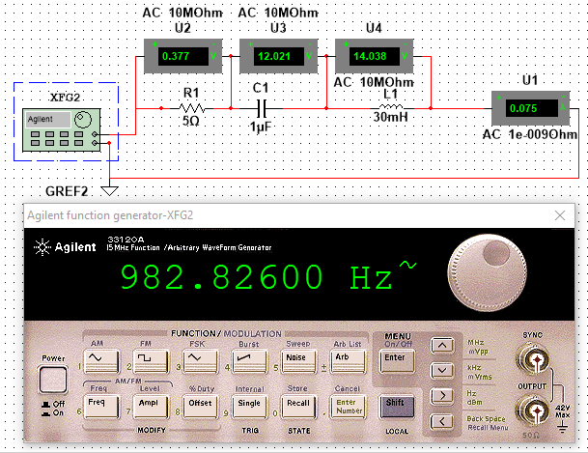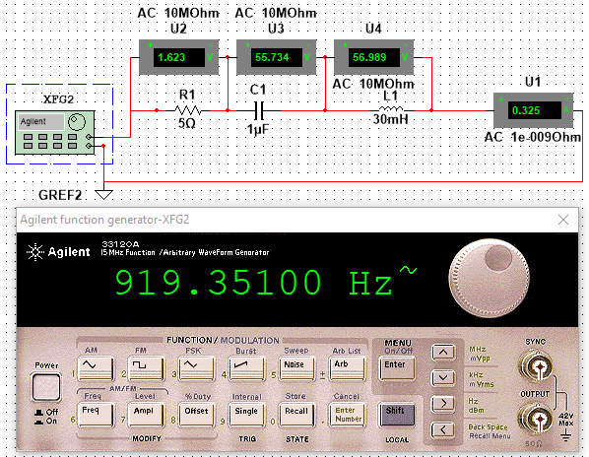

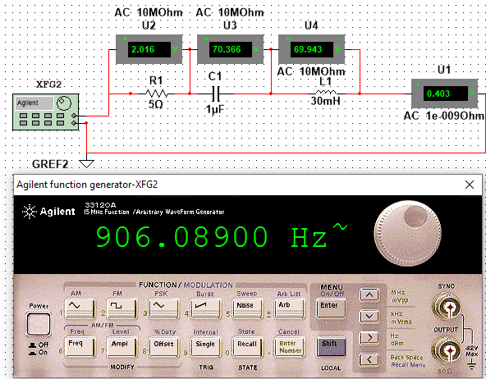

Table 4

R=50-ohm, L=30mH, C= 1uF

|  |  |  |  |  |  |  |  |  |  |
| --- | --- | --- | --- | --- | --- | --- | --- | --- | --- |
| f/Hz |  |  | f1 | 786.37 | f0 | 919 | f2 | 1051.63 |  |
| Ur/A |  |  | U1 | 1.464 | U0 | 2.057 | U2 | 1.453 |  |

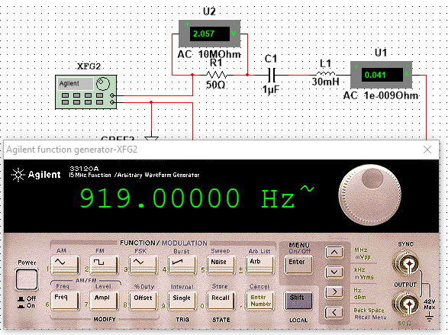

3. When voltage values on inductor and capacitor are the same, the resonance frequency is found. Record maximum voltage Umax on resistor, then found half power frequency.

Table 5

R=5-ohm, L=30mH, C= 1uF

|  |  |  |  |  |  |  |  |  |  |
| --- | --- | --- | --- | --- | --- | --- | --- | --- | --- |
| f/Hz |  |  | f1 | 890.989 | f0 | 904.252 | f2 | 917.514 |  |
| IR/A |  |  | IR 1 | 0.243 | IR0 | 0.389 | IR2 | 0.346 |  |
| UR/V |  |  | UR1 | 1.216 | UR0 | 1.943 | UR2 | 1.731 |  |
| UL/V |  |  | UL1 | 41.243 | UL0 | 67.218 | UL2 | 60.752 |  |
| UC/V |  |  | UC1 | 42.858 | UC0 | 67.892 | UC2 | 59.647 |  |

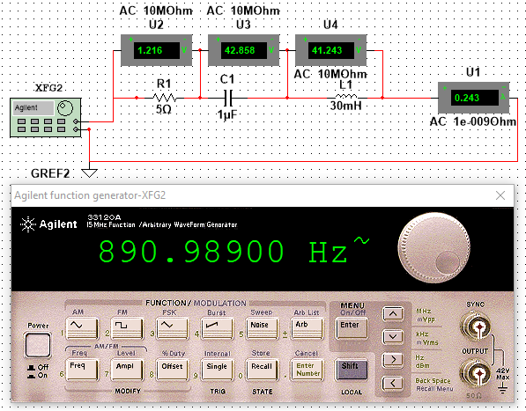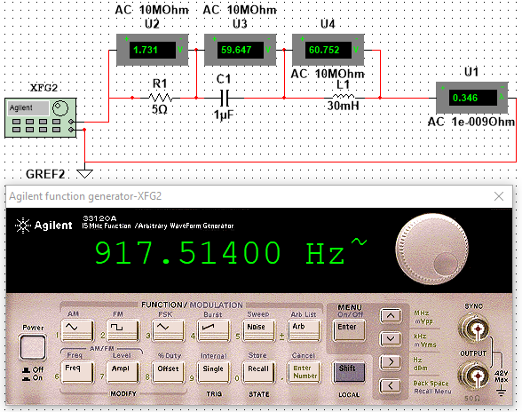

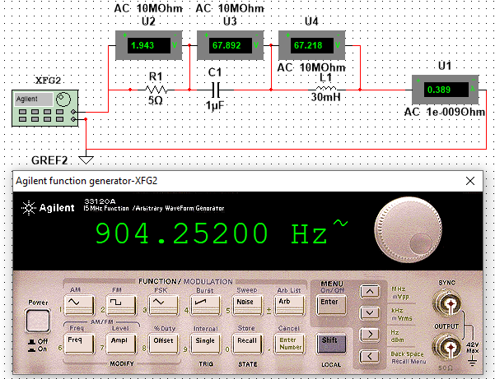

Table 6

R=50-ohm, L=30mH, C= 1uF

|  |  |  |  |  |  |  |  |  |  |
| --- | --- | --- | --- | --- | --- | --- | --- | --- | --- |
| f/Hz |  |  | f1 | 771.28 | f0 | 903.91 | f2 | 1036.53 |  |
| IR/A |  |  | IR 1 | 0.027 | IR0 | 0.041 | IR2 | 0.031 |  |
| UR/V |  |  | UR1 | 1.37 | UR0 | 2.062 | UR2 | 1.527 |  |
| UL/V |  |  | UL1 | 4.203 | UL0 | 7.222 | UL2 | 6.099 |  |
| UC/V |  |  | UC1 | 5.574 | UC0 | 7.223 | UC2 | 4.65 |  |

